**Problem 1: Read the instructions carefully and answer accordingly. If there is any need to insert some data then do that as well.**

**a) Navigate and List:**

**a. Start by navigating to your home directory and list its contents. Then, move into a directory named "LinuxAssignment" if it exists; otherwise, create it.**

Answer:-

I have used cd command to navigate it into home directory, Then i have used ls command to see which directoryies are present. As i dont have LinuxAssigment so i have created it using cd LinuxAssigment command.

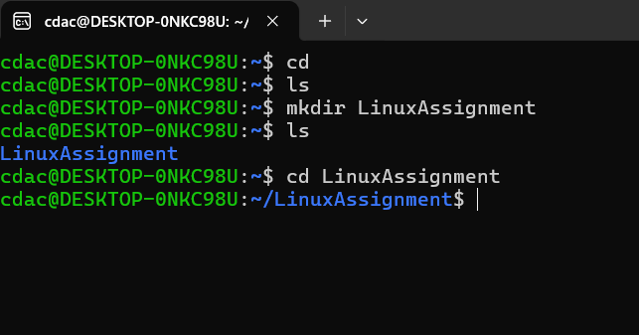

b) File Management:

a. Inside the "LinuxAssignment" directory, create a new file named "file1.txt". Display its contents.

Answer:-

to go into LinuxAssignment i have used cd LinuxAssignment command, Then i have created new file file1.txt using touch file1.txt command, to display its content i have to open that file into editor mode so i have write a comman called nano file1.txt, then with the help of echo i have written "I am learning Linux" and saved it. and to display it on command line i have used command called cat file1.txt.